Project Development PhaseSprint III

Sprint Targets :
Date | 15 November 2022
Team ID | PNT2022TMID44492
Project Name | Signs with Smart Connectivity for better road safety
Sprint | Functional Requirement (Epic) | User Story Number | User Story / Task | Story Points | Priority | Team Members
Sprint-3 | Login | USN-5 | As an administrator , I should have an account of the website | 7 | Low | Pavithra Rohini Naresh Mallisri
Sprint-3 | Dashboard | USN-6SSS | As an admin , I should be able to monitor and add sign nodes | 13 | Medium | Pavithra Rohini Naresh Mallisri

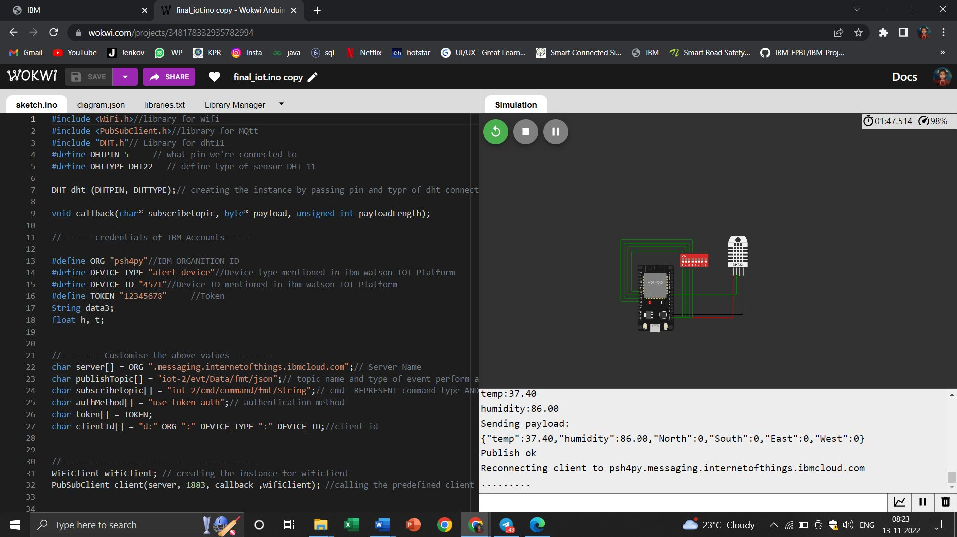
Wokwi Simulation: https://wokwi.com/projects/348178332935782994

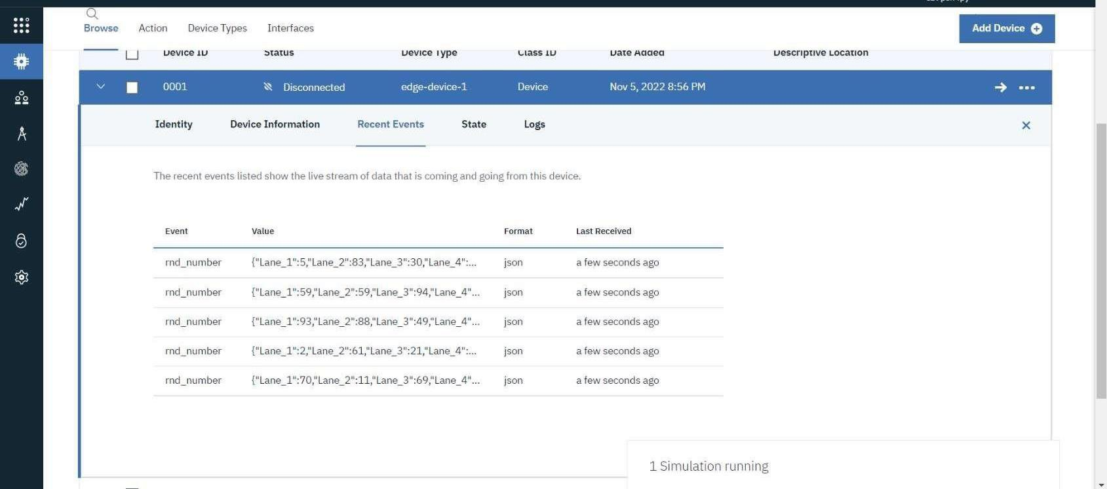
IoT Device – IoT Platform

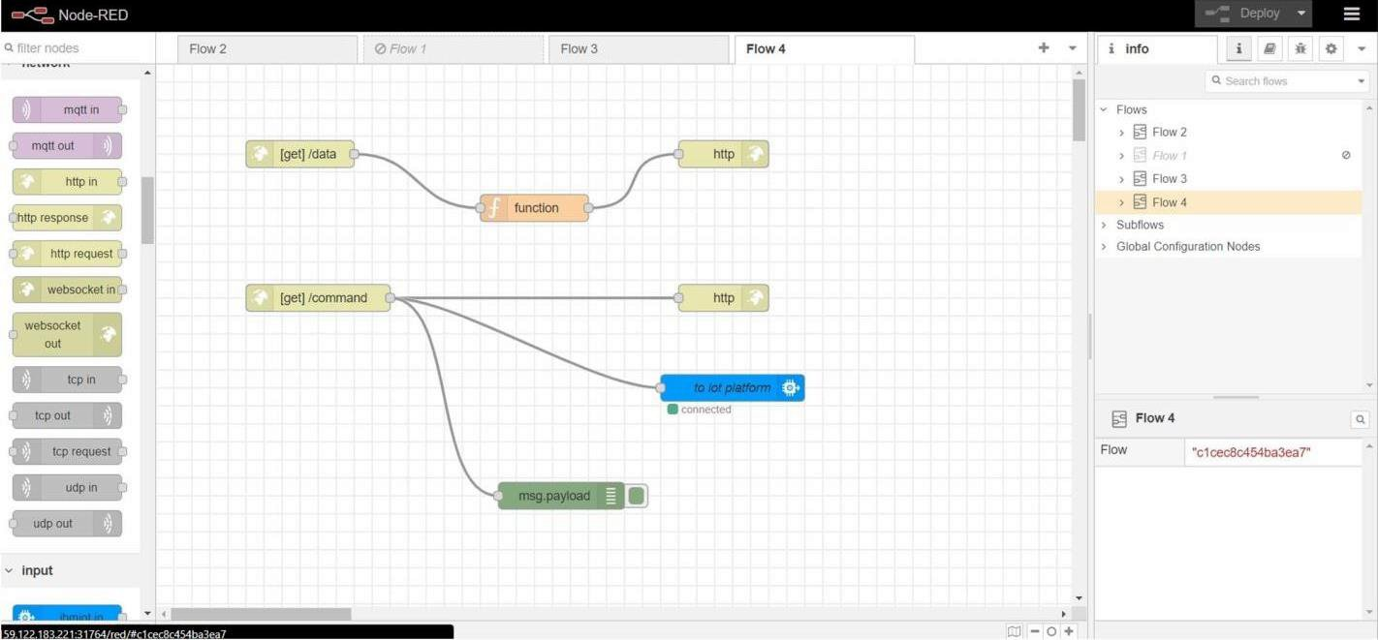
Node Red – Connect with MIT AppInventor
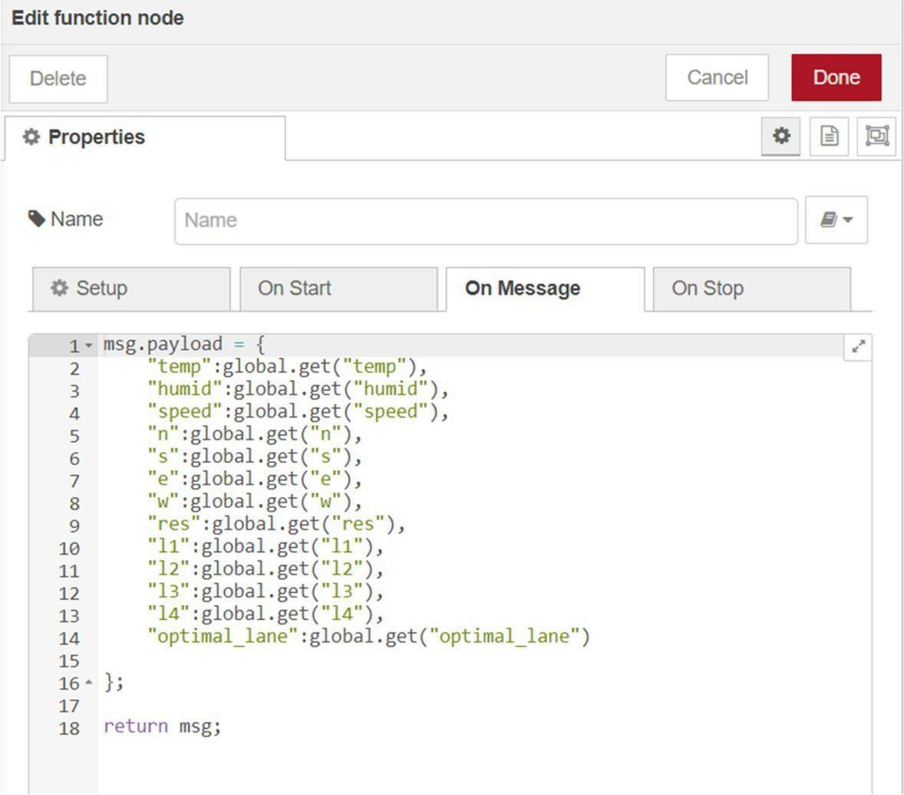
Output from Node red:

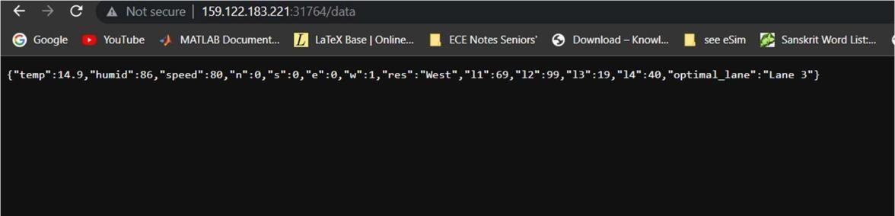
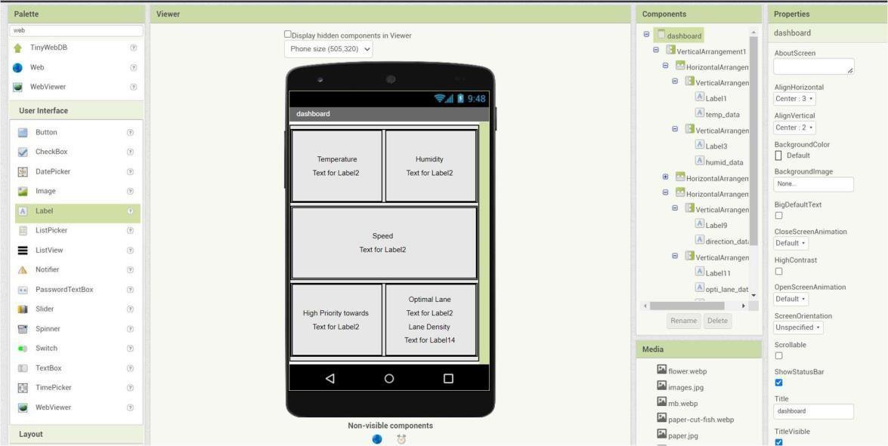
MIT App Inventor UI design:
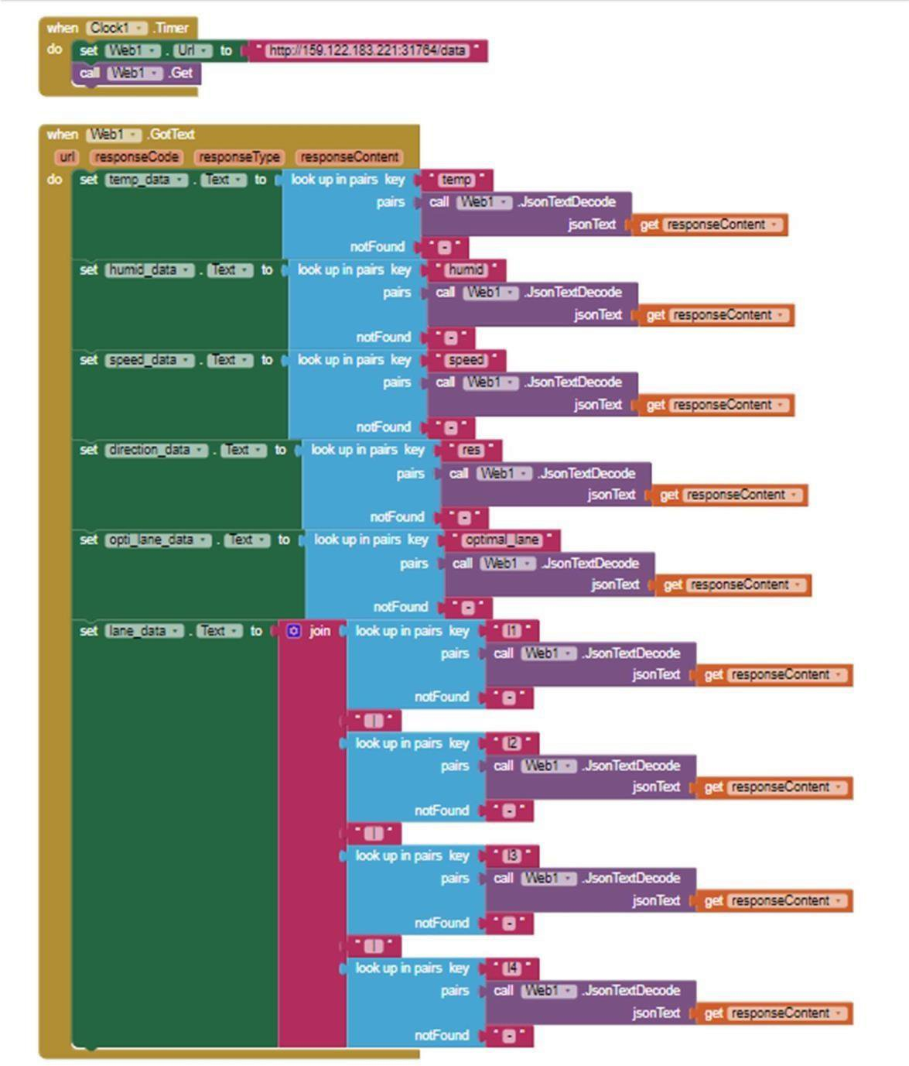
MIT App Inventor Backend design:
Sprint 3 delivery:
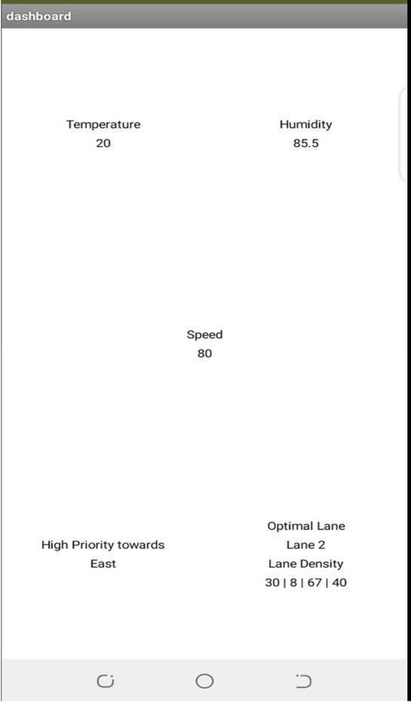
(OUTPUT) Display from MIT App:

